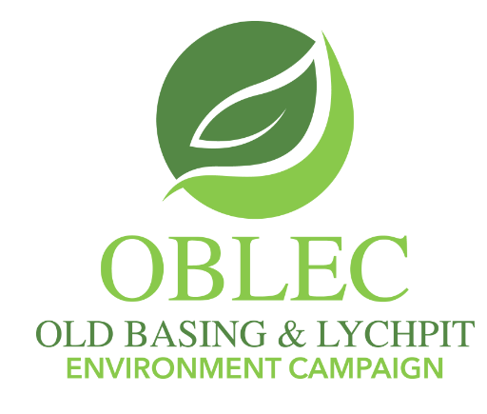

The Local Plan Update public consultation has started

Dear OBLEC supporter

The public consultation on the Local Plan Update has started - known as Regulation 18 - and this runs until midnight on Monday 4 March 2024. Individual responses do count, so please have your say. This 4.5 minute OBLEC drone tour video of the Land East of Basingstoke site, produced last year, illustrates its constraints:

https://www.youtube.com/watch?v=Vrijaifvrs0
(Note: Produced when site ref was SS3.6 and adjacent site ref was SS3.7 and included in the Local Plan)

You can find the Update at:

Local Plan Update

The contact details for responding to the public consultation on the Local Plan Update can be found here: https://www.basingstoke.gov.uk/LPU-have-your-say

By email or post
Response forms are available at the council offices or can be downloaded below and returned by email to Local.plan@basingstoke.gov.uk or by post to: Civic Offices, London Road, Basingstoke, RG21 4AH. Alternatively call 01256 844844 to be sent a response form.

Consultation response form(DOCX) [456 kb]
Consultation response form(PDF) [221 kb]

Alan Renwick
For the OBLEC Committee

