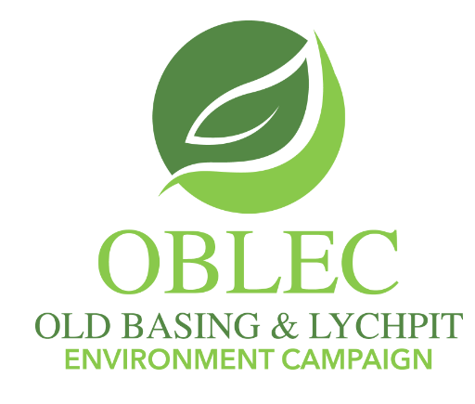

Good News!

Dear OBLEC supporter

On Tuesday 19th December 2023 we received details of the draft Local Plan update from the Borough Council.

Happily, Lodge Farm and Hodds Farm are not listed in the allocated sites and the Cabinet meeting of B&DBC on 9th January 2024 ratified that position. So these two sites have been removed from this update.

The Site Selection report gives the following conclusions as to why this is the case:

‘Lodge Farm: Conclusion: … the site is quite constrained and whilst some of the constraints may be addressed by combining the development of this site with OLD001 (East of Basingstoke) and through mitigation, there remains a number of constraints particularly due to the site’s proximity to the river Loddon, the sewage treatment works and heritage assets. Therefore, this site is not proposed for allocation.

Hodds Farm: Conclusion: The site was initially considered as a shortlisted site for potential allocation. However, as was flagged at that stage, the site is considered to have a number of notable constraints and was one of the most constrained sites that was shortlisted for further consideration. While the highlighted constraints may be able to be mitigated to some extent this has not been established at this stage, and given that there are other more suitable sites, it is not proposed for allocation.’

The Local Plan lists the Land East of Basingstoke (OLD-001) as a development site remaining inside our Parish boundary. (This site was part of the Local Plan agreed previously in 2016.) Originally, the housing number was 450 but Hampshire County Council wants to bring forward a further 450 houses, thus making the housing number 900.
Regarding OBLEC and Parish Council activity in 2023, it is worth noting that, in a note to Parish Clerks on 18th December, the Borough Council stated:

‘The Spatial Strategy - the Council has listened to the comments made at the Economic, Planning and Housing Committee (EPH) meeting in September and has removed three of the sites from the Spatial Strategy: Lodge Farm, the land west of Upper Cufaude Farm and Skates Lane. The former Portals site in Overton has been included as a proposed allocation and the number of new homes in the town centre has increased.’

Alastair Rudman, Nick Harris and I each addressed the EPH meeting on
7th September 2023. We were listened to then. Also listened to again, when Borough Councillors Paul Harvey and Andy Konieczko visited the Parish Council on 31st October 2023.

May we express our grateful thanks to all those who turned out for the OBLEC demonstration outside the Borough Council offices on 7th September.

You can view the Local Plan update at:

https://democracy.basingstoke.gov.uk/ieListDocuments.aspx?CId=142&MId=2320&Ver=4

See Appendix 4: Site Selection Report to inform Regulation 18 consultation (2023)

Next steps

We have to accept that houses are likely to be built on the Land East of Basingstoke site. However, we continue to have concerns about several matters: The issues of odour from the Sewage Treatment Works, noise from the incinerator, heritage, valued biodiversity and flood risk (Flood Zones 2 and 3a). Having built the facilities away from housing it cannot make sense to bring the houses near to the facilities now.

We expect the Regulation 18 public consultation on the Local Plan update to start soon. This runs for a period of 6 weeks. Once we have more information on this we will be in touch again.

Alan Renwick
For the OBLEC Committee

