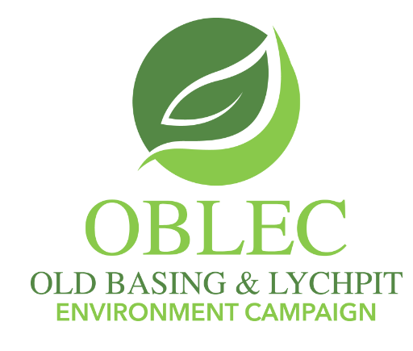
Sand building?
The foolish man built his house upon the sand fields next to Old Basing.
Where to build 900+ houses? Next to a sewage works, an incinerator and on top of an ancient monument. Doesn't sound ideal?
Well, that is where the Borough Council and Hampshire County Council want them. Namely, in the fields of Old Basing and Lychpit, opposite Chineham.
It gets worse. The site's only point of road access for its 1300+ vehicles would cross a floodplain, the development would destroy one of Basingstoke's top walks, mean a roundabout is plonked onto the tiny roads of Old Basing and it all comes with no GP/dental resource.
Hampshire County Council held (poorly advertised) drop-in sessions. They said they've listened to parishioners' concerns. They haven't. Nothing has changed since last years' sessions.
Why not? Because most of the site's problems are unsolvable. It is simply unsuitable for 900+ houses. The proverb 'trying to make a silk purse out of a sow's ear’ comes to mind.
There is housing pressure in the south-east. However, that doesn't excuse poor planning.
Who will suffer? Not the developers, but existing parishioners and future ones.
The Old Basing and Lychpit Environmental Campaign consulted 'Plume Plotters'. Using official Veolia data, they showed residents of the site will get exposed to more pollution than elsewhere in the borough (oblec.org.uk/news/). This (polluting/stinky) 'elephant in the room' remains ignored.
Want to help? Respond to the borough's 'Have your say on the Local Plan' by March 4. Numbers matter (the site is SPS5.6). I also encourage the council to prove the cynics wrong, show their consultation is genuine and that everything is not just 'a done deal.'
Dr A Noble
Merrydown Lane
Chineham

