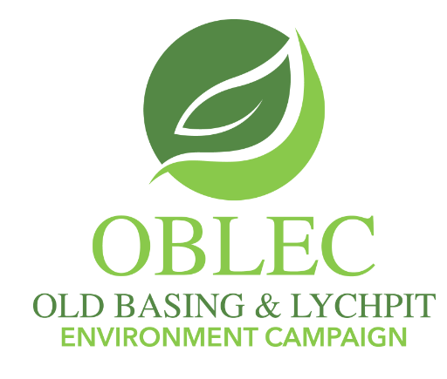

Well done on plan
I join with everyone in congratulating our Borough Council, its officers, and elected members, on the production of the Basingstoke's Local Plan Update.

It is a fantastic and important document that must have taken all those involved an immense amount of effort to reach this stage.

As its beneficiaries, those who live in the borough should both be very grateful and should make their comments known too.

One of the sites, labelled SPS5.6 ‘The Land East of Basingstoke’ proposes 900 new homes in the vicinity of the sewage farm and incinerator off the A33, presumably placed there precisely as to be away from people's homes.

Chineham and Lychpit residents commonly smell - and hear- these essential works and it seems foolhardy, unkind even, to consider building even closer to these facilities.

The commonly applied definition for odour nuisance is '.... the cumulative effect on humans, of repeated events of annoyance caused by exposure to odours, over an extended period, that leads to modified or altered behaviour.'

We should not build there because the buyers will suffer. It would be an immoral thing to do.

Nick Harris
Milkingpen Lane
Old Basing

